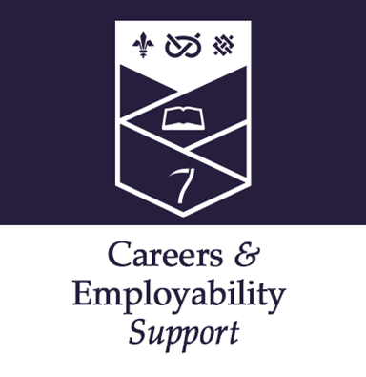
Master’s students
Being your best self at interview
The interview – face to face or virtual is the chance to verbally articulate what you have presented in your application. Take this opportunity to covey the knowledge and skills-set from your master’s course to maximise the learning gain from the process.
Use the resources in the Compete section of Keele Careers Online (KCO) in order to gain more top tips and practise using the interview simulation tool: https://www.keele.ac.uk/kco/
Do:
- Re-read your application so you know what you have told them about yourself and reflect upon what they are likely to ask you; how you have made choices in the past, why you chose your master’s course, what skills you have developed from your part time work or volunteering…

- Research the recruiter in depth so you know what they do and how they do it as well as being aware of their competitors and what is happening in their sector.

- Know what the job or training scheme involves so that you can convince them that you are genuinely interested rather than just want a job.

- Practise talking about yourself… you need to be able to describe yourself and articulate what motivates you – they are interested.

- Develop an evidence base for the skills and knowledge you know they are seeking. If they are looking for excellent teamwork skills you need to have examples to evidence these.

- Show enthusiasm. Many recruiters feel that they can develop skills and knowledge but not attitude so make your enthusiasm clear.

- For video/virtual interviews, make sure that you are comfortable with the technology before you begin and that the setting is quiet, undisturbed and uncluttered. Dress and prepare as you would for a formal interview.

Don’t:

- Arrive far too early so that you have too much time to become nervous but do make sure you aren’t late. Some recruiters will even refuse to see you if this is the case.

- Avoid looking at the interviewer/s. Eye contact is critical as it forms the basis of most person-to-person communication.

- Give a limp, sweaty handshake. Practise before you go and make sure your handshake is firm and dry!

- Wear your comedy tie or clubbing gear. Bear in mind the dress code for the role and organisation. A suit is not right for every interview but you need to wear what is appropriate for the recruiter.

- Blag it if you don’t know the answer to a question. It is far better to be honest than dig a hole for yourself. It is fine to ask for thinking time or ask for a rephrasing of the question and consider if you can answer part of it if not all of it but make it clear you know you are doing this.

You can also book an appointment with a Careers Consultant to discuss your application: https://www.keele.ac.uk/careers/

Also see:

https://targetjobs.co.uk/careers-advice/interview-types
https://www.prospects.ac.uk/careers-advice/interview-tips
https://targetjobs.co.uk/careers-advice/interview-types/323749-expert-performance-tips-for-skype-and-video-interviews

You can also book an appointment with a Careers Consultant to discuss your application: https://www.keele.ac.uk/careers/

SLSEPT2023

